You are invited to the

Dedication of the Lincoln school bell

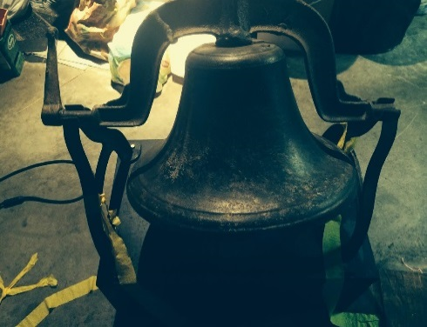

aT the administration building of the

Fayette r-iii school district

In honor and memory of Lincoln public school

1871-1966

Friday, September 4, 2015

10:00 a.m.

705 lucky street

Student presentations

Guest speakers

Tour the new administration building

Refreshments will be served